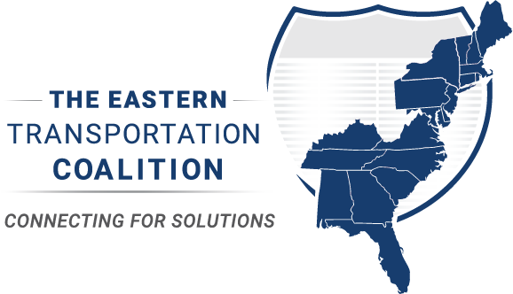

National CAV Day Communications Plan and Strategy
October 8, 2022

Overall Goal: Awareness and education for the general public on the benefits of Connected and Automated Vehicles (CAV) in any or all of the following areas: safety, technologies, economy, mobility, deployments, data, privacy, long-range planning, operations, freight, transit, education, outreach, research, pilots, personal delivery devices and Operational Design Domains.
Why October 8? The somewhat arbitrary date for AV day was selected for Memorial Day weekend. Transportation agencies are far too busy to focus on AV day at this time – the start of construction season and the start of some of the busiest days of travel for the general public. MVA identified a date of October 8 to align with the DARPA Grand Challenge (2005).
A majority of this strategy will be focused on Advanced Driver Assistance Systems (ADAS) information but could grow and be modified as needed. This is the reason for the lengthy list of additional possible focus areas listed in the goal statement.
General Notes:
- This outreach effort will start small and build over time. Deliverables are noted below for 2023 and beyond.
- It is unknown who originated the original “Automated Vehicle” designation. The scope of this outreach project will incorporate Connected Vehicles as well as shift the language from Autonomous to Automated.
- This outreach effort will align with other initiatives:
  - The Eastern Transportation Coalition (TETC) ADAS outreach effort in partnership with the Partners for Automated Vehicle Education (PAVE)
  - Ongoing education work with JD Power
  - Regional efforts such as the Maryland Department of Transportation’s education outreach work
Key audience(s) (listed in order of importance): General public, young drivers, elected officials, key stakeholders, sister transportation agencies, sister safety agencies, law enforcement, CAV professionals.
Strategies and Tactics:
Strategy 1: Increase awareness about the safety of ADAS features for the general public
Tactic: Use social media to stress the importance of ADAS for safety and mobility.
Strategy 2: Educate and inform key stakeholders about ADAS
Tactic: Create a Governor proclamation document that highlights public agency commitment to exploring, implementing, and educating about ADAS.
Tactic: TETC participate in a September PAVE webinar about this effort, introduce the new CAV day and share the goals and strategies of the outreach effort.
Strategy 3: Provide a coordinated, simple to use and easy to implement toolkit for public agencies to use that can assist with creating common terminology between agencies.
Tactic: Create a toolkit that has key messaging, graphics, social media copy, a proposed editorial calendar with drafted posts and opportunities to coordinate and share information regarding ADAS.
Tactic: Create a mechanism to collect metrics for engagement regarding ADAS. This can help with campaign strategy and for baseline data on the understanding and awareness of ADAS among the general public. Maryland DOT uses a Brandwatch mechanism for sentiment tracking, etc. It would be beneficial if other task force agencies use something similar to track engagement. Maryland DOT can also set up a query for their social media channels.
Partners:
In future years, this outreach effort could include PAVE, AAMVA, NHTSA, JD Power and additional Coalition state partners.
Deliverables:
This year:
Editorial calendar for social (see appendix 1)
Governor proclamation (see appendix 2)
Graphics for social (see appendix 3)
Key Messaging/toolkit for agencies (see appendix 4)
Possibly in the future:
Press event
Explainer video series
Additional partner engagement

The Task Force:
This will be the key stakeholder group from Coalition states, helping to guide the development of CAV Day. The task force members will forward CAV Day in their own states once the outreach plan has been fully developed.
- The Eastern Transportation Coalition
- Maryland Department of Transportation
- DC Department of Transportation (invited)
- Virginia Department of Transportation (invited)
- Pennsylvania Department of Transportation (invited)
- Partners for Automated Vehicle Education (PAVE) (invited)
- Georgia Department of Transportation (invited)

Appendix 1 – Social Media Editorial Calendar
September 12, 2022
Copy: Our agency mission is to make roads safe. Many technologies help to improve safety, especially Connected and Automated Vehicles. We’re celebrating the first ever National CAV Day in just one month! Want to learn more? Keep an eye out for posts with facts, myth-busting, education and more on our feed! #nationalcavday #automated vehicles #connectedvehicles #safety #ADAS

Alternative (shorter) copy: Many technologies help to improve roadway safety. We’re celebrating the first ever National CAV Day in one month!
Graphic:

September 30, 2022
Copy: The first ever National CAV Day is almost here! What is CAV? @USDOT has a comprehensive plan for CAV. At {{YOUR AGENCY NAME}}, we also have a strategic plan that incorporates CAV elements into our transportation and mobility network. #nationalcavday #automated vehicles #connectedvehicles #safety #ADAS
Link to Agency CAV plan
Alternative (shorter) text: What is CAV? @USDOT has a comprehensive plan for it. Check out our {{YOUR AGENCY NAME}} strategic CAV plan here: LINK.
Graphic:
October 4, 2022
Copy: Do you know your car? Advanced Driver Assistance Systems (ADAS) are in over 90% of new cars. Do you know what your car has available? Search here to see what technologies maybe in your car. These vehicle technologies are designed to protect you and others on the road. #nationalcavday #automated vehicles #connectedvehicles #safety #ADAS
https://www.consumerreports.org/automotive-technology/how-much-automation-does-your-car-really-have-level-2-a3543419955/

https://www.nhtsa.gov/equipment/driver-assistance-technologies#the-topic-tech-in-your-car

https://www.trafficsafetymarketing.gov/get-materials/vehicle-safety/advanced-technologies

Alternative (shorter) text: Advanced Driver Assistance Systems (ADAS) are in over 90% of new cars (consumer reports link). Do you know what your car has available? Search here to see what technologies maybe in your car. These vehicle technologies are designed to protect you and others on the road. DO NOT turn them off!

Link to:
https://www.consumerreports.org/automotive-technology/how-much-automation-does-your-car-really-have-level-2-a3543419955/

https://www.nhtsa.gov/equipment/driver-assistance-technologies#the-topic-tech-in-your-car

Graphic:
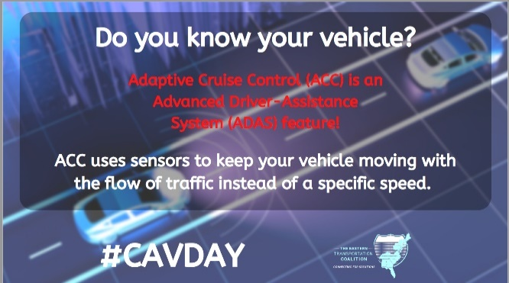

October 7 or October 8, 2022 (Post on Friday, October 7, or Saturday October 8).
Copy: Today is the first ever National Connected and Automated Vehicles (CAV) Day! CAV is one technology tool that we use at {{AGENCY NAME}} to help make travel safer for all citizens. Today’s cars have features called advanced driver assistance systems (ADAS). These features are designed to increase the safety of driving a vehicle. Educating drivers about the features and uses of ADAS technologies is an essential part of roadway safety! #nationalcavday #automated vehicles #connectedvehicles #safety #ADAS
Alternative (shorter) text: Today is the first ever National Connected and Automated Vehicles (CAV) Day! Today’s cars have Advanced Driver Assistance Systems (ADAS) features that increase the safety of driving a vehicle.
Graphic: Governor proclamation or

October 11, 2022
Copy: Do you know your car? Pedestrian Detection (PD) is an advanced driver assistance system (ADAS) that detects pedestrians (and sometimes bicyclists and pets) in a vehicle's path. Once a risk is detected, Pedestrian Detection provides an audible, visual, or haptic warning to drivers. Some Pedestrian Detection systems just provide a warning. #nationalcavday #automated vehicles #connectedvehicles #safety #ADAS

Alternative (shorter) text: Pedestrian Detection is an advanced driver assistance system that detects pedestrians in a vehicle’s path. Once a risk is detected, the driver gets an audible or visual warning.

Graphic:
October 18, 2022
Copy: Do you know your car? Lane Keeping Assist is an Advanced Driver-Assistance System (ADAS) feature! All systems are not created equal. Make sure you know how your vehicle operates and always keep your hands on the wheel and pay attention to the road. #nationalcavday #automated vehicles #connectedvehicles #safety #ADAS
https://www.consumerreports.org/car-safety/lane-departure-warning-lane-keeping-assist-guide-a7087080070/
https://www.nhtsa.gov/equipment/driver-assistance-technologies#the-topic-tech-in-your-car

Alternative (shorter) text: All systems are not created equal. Make sure you know how your vehicle operates and always keep your hands on the wheel and pay attention to the road.

Link to:
https://www.nhtsa.gov/equipment/driver-assistance-technologies#the-topic-tech-in-your-car https://www.consumerreports.org/car-safety/lane-departure-warning-lane-keeping-assist-guide-a7087080070/
Graphic:
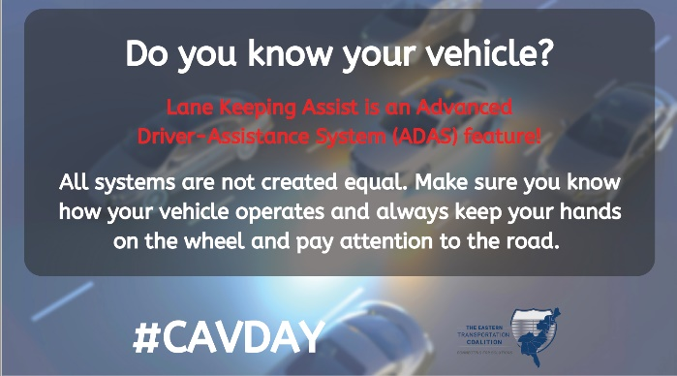

November 8, 2022
Copy: Do you know your car? Advanced crash avoidance is an advanced driver assistance system feature! Features like automatic emergency braking, lane departure warning, and blind spot detection can prevent injuries, save lives, and prevent crashes. #nationalcavday #automated vehicles #connectedvehicles #safety #ADAS
https://www.iihs.org/media/290e24fd-a8ab-4f07-9d92-737b909a4b5e/4GauQQ/Topics/ADVANCED%20DRIVER%20ASSISTANCE/IIHS-HLDI-CA-benefits.pdf

Alternative (shorter) text: Automatic emergency braking, lane departure warning, and blind spot detection can prevent injuries, save lives, and prevent crashes.

Link to:
https://www.iihs.org/media/290e24fd-a8ab-4f07-9d92-737b909a4b5e/4GauQQ/Topics/ADVANCED%20DRIVER%20ASSISTANCE/IIHS-HLDI-CA-benefits.pdf

Graphic:

December 8, 2022
Copy: Do you know your car? Today’s vehicles are the future of driving. Make sure you know what your vehicle does and how it operates. You can find out more information here. Remember – there are no FULLY Automated vehicles on the road today. Hands on the wheel and eyes on the road. Every crash is preventable! #nationalcavday #automated vehicles #connectedvehicles #safety #ADAS
Link to Zero Deaths program in your state
https://www.nhtsa.gov/equipment/driver-assistance-technologies#the-topic-tech-in-your-car

Alternative (shorter) text: Remember – there are no FULLY Automated vehicles on the road today. Hands on the wheel and eyes on the road. Every crash is preventable! Make sure you know what your vehicle does and how it operates.

Link to: https://www.nhtsa.gov/equipment/driver-assistance-technologies#the-topic-tech-in-your-car
https://zerodeathsmd.gov/

Graphic:

January 2023 – September 2023: Use graphics and copy as needed from:
- https://article.images.consumerreports.org/image/upload/v1658777041/prod/content/dam/CRO-Images-2022/Cars/07July/Clearing-the-Confusion-7-26-22.pdf
- https://www.trafficsafetymarketing.gov/get-materials/vehicle-safety/advanced-technologies
Appendix 2 – EXAMPLE of Governor Proclamation
Connected and Automated Vehicle Awareness Day
WHEREAS, distracted driving is an epidemic on our roadways, claiming thousands of lives and injuring hundreds of thousands each year in the United States; and,
WHEREAS, informing drivers of the safety benefits of Advanced Driver Assistance Systems (ADAS) is of critical importance for driver understanding and improving safety on our roadways; and,
WHEREAS, state Departments of Transportation seek to work with industry partners, elected officials, and the general public to educate and inform; and,
WHEREAS, INSERT STATE SPECIFIC AV LEGISLATION HERE [referencing the efforts of the state DOT for AV implementation and awareness]; and,
WHEREAS, increased awareness about the benefits of ADAS technologies may reduce traffic fatalities and injuries in STATE; and,
WHEREAS, a day dedicated to programs and activities focused on ADAS education will greatly raise awareness;
NOW, THEREFORE, I, GOVERNOR, do hereby recognize October 8 2022 as CONNECTED AND AUTOMATED VEHICLE AWARENESS DAY in our STATE OF XXXXXXXX, and I call this observance to the attention of our citizens.

Appendix 3 - Graphics for social

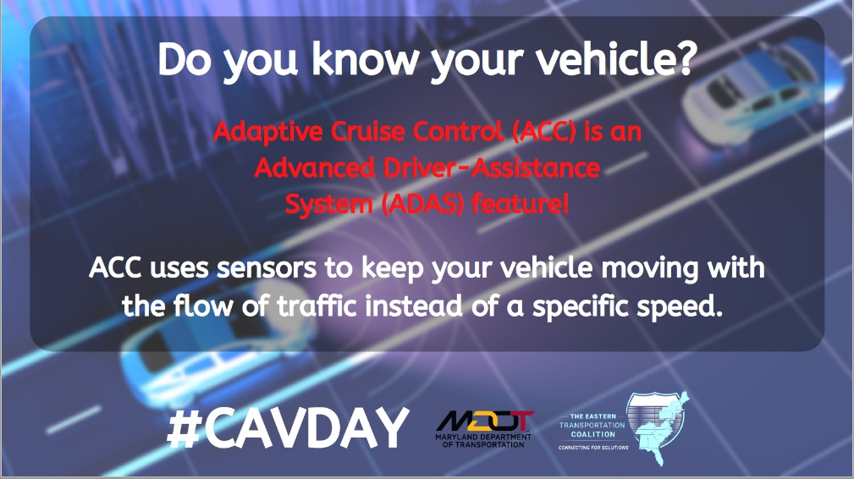
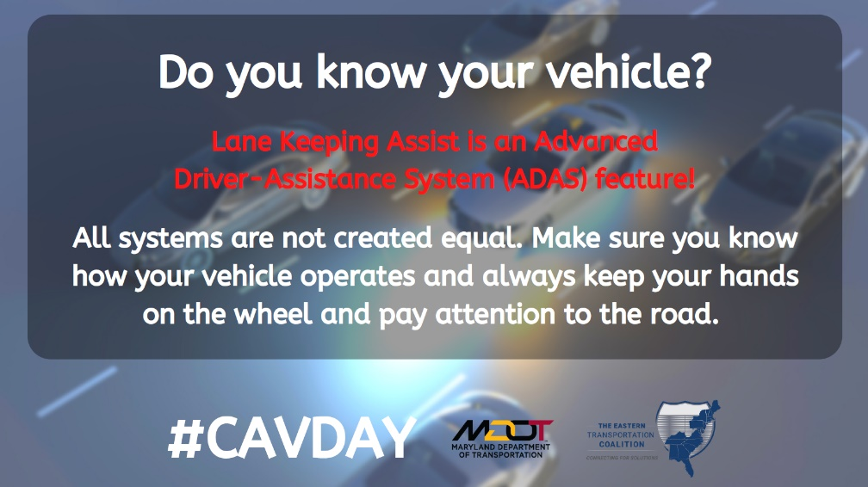

Appendix 4 - Key Messaging/toolkit for agencies
Key Messages:
- Many vehicles on the roadway today have ADAS and ADS features that can help to improve safety.
- Driver education is very important in understanding the safety benefits of ADAS features.
- Public agencies are committed to enhancing roadway safety through education and awareness of vehicle features.

Important Points:
- Many citizens are unaware of the ADAS features on their vehicle, or how to use them properly.
- Many citizens believe that some driver assist features make their vehicle a self-driving car – this is incorrect.
- Some ADAS features that assist with the driving experience are: adaptive cruise control, lane keeping assist, automatic parking, blind spot detection and tire pressure monitoring.
- Some ADAS features that assist with making driving safer are: driver drowsiness detection, wrong way driving warning, traffic sign recognition and forward collision warning.
- Every year in the United States, there are an unacceptable number of fatalities on our roads. Highway Safety Offices are all working on a Vision Zero campaign to reduce crashes, injuries and fatalities.

Appendix 5 – Additional Details

ADAS features deliver a more comfortable driving experience and improve driving safety
- Adaptive cruise control
- Glare free high beam and pixel light
- Anti-lock braking system
- Automatic parking
- Automotive navigation system
- Automotive night vision
- Blind spot detection system
- Collision avoidance system
- Crosswind stabilization
- Intelligent speed adaptation
- Lane centering
- Lane departure warning system
- Lane change assistance system
- Surround view system
- Tire pressure monitoring
- Driver drowsiness detection
- Driver monitoring system
- Electric vehicle warning sounds
- Emergency driver assistance
- Forward collision warning
- Intersection assistant
- Hill descent control
- Wrong way driving warning
- Vehicular communication system
- Traffic sign recognition

Appendix 6 – AV Timeline

https://www.roadtraffic-technology.com/comment/autonomous-vehicles-timeline/
Listed below are the key milestones that tell the story of AVs, as identified by GlobalData.
1939 – GM’s Futurama exhibit at the World’s Fair envisages cars that drive themselves.
1953 – GM and RCA develop a model automated highway to experiment with electronics to control steerage and distance between vehicles.
1958 – GM tests a rudimentary self-steering Chevrolet.
1960s – Stanford University roboticists develop the autonomous Stanford Cart based on the Lunar Rover platform.
1977 – Dr Sadayuki Tsugawa unveils first fully AV equipped with cameras and analogue signal processing computers at the Mechanical Engineering Lab at Japan’s Ministry of International Trade and Industry.
1979 – Stanford’s Hans Moravec’s Stanford Cart crosses a chair-filled room without incident or human intervention.
1987 – Aerospace engineer Ernst Dickmanns’ VaMoRs vehicle outfitted with two cameras, 18 16-bit microprocessors, and a host of sensors self-drove for 20km at an average speed of 56mph.
1994 – Dickmanns piloted a retrofitted Mercedes S-Class from Munich to Odense, covering roughly 95% of the distance autonomously.
1995 – A team of CMU roboticists drove a 1990 Pontiac from Pittsburgh to LA with a 70-mile stretch completed without human help.
2005 – Defence Advanced Research Projects Agency (DARPA) stages a Grand Challenge for robot vehicles to complete a 132-mile course full of bends and mountain passes. Stanford University wins with its Stanley VW, completing the course in 6 hours and 54 minutes.
2009 – Google starts testing robot cars on roads.
2015 – Tesla unveils Autopilot.
2015 – Baidu drives a retrofitted BMW 3 Series autonomously in Beijing.
2015 – Delphi AV drives from coast to coast.
2016 – Uber test autonomous taxis with human co-pilot in Pittsburgh.
2017 – NuTonomy self-drive taxis tested in Singapore.
2017 – Gallup poll in the US shows majority public concern about AVs.
2018 – March: Uber AV with human safety driver on board kills a pedestrian in Arizona.
2018 – Autonomous lorries start to test on highways in the US and UK.
2018 – Nissan-DNA launch self-drive experiment in Yokohama.
2018 – Waymo runs a limited commercial robotaxi service in Chandler, Arizona.
2019 – Tesla touted full autonomy would be available in its vehicles, it still has not achieved this target.
2020 – GM launches Origin robotaxi with Lyft.
2020 – Volvo and Uber announce plan for robotaxi service with Geely and Nvidia.
2022 – Maryland is the first state in the nation to add substantial ADAS information to their novice drivers’ manual.

https://youtu.be/_HbVWm7wdmE
https://www.cs.cmu.edu/~tjochem/nhaa/Journal.html
https://www.youtube.com/watch?v=h7tO-4FoKCo
https://highways.dot.gov/public-roads/julyaugust-1997/demo-97-proving-ahs-works
Appendix 7 – One page summary

National Connected and Automated Vehicle (CAV) Awareness Day Summary
What: A day of awareness and education for the public, focusing on Advanced Driver Assistance System (ADAS) vehicle features.
When: Saturday, October 8, 2022 (Observed Friday, October 7, 2022). October 8 in future years.
Where: Mostly online! There is a social media toolkit for agencies to utilize. The toolkit also includes a Governor’s Proclamation if public agencies wish to do a press release and have Governor support.
Why: Many vehicles on the road today have some ADAS-equipped features. Driver understanding and awareness of these features will help to make roads safer. There is a growing body of public outreach for ADAS so this effort is timely. Public agencies have a unique opportunity to assist private sector and governmental agencies like PAVE, NHTSA and JD Power to amplify ADAS messaging.
For more information or to participate: Please contact Lisa Miller (limiller@tetcoalition.org)!

